

INTERNATIONAL ISLAMIC UNIVERSITY MALAYSIA

KULIYYAH OF INFORMATION TECHNOLOGY AND COMMUNICATION

WEB APPLICATION DEVELOPMENT

(INFO 3305)

*“Health is Wealth” prepared by HMS*

Submitted to:

Najhan Muhammad Ibrahim

Group Members:

|  |  |
| --- | --- |
| Mohammad Tahmid Lodi | 1725491 |
| Junayed Md Khaled Bin Oalid | 1717457 |
| Sultan Syafriyudi Mahidin | 1721899 |
| Ali Mohammed Alattas | 1536481 |

Section 3

Semester 1, 2019/2020

**Table of Contents**

|  |  |  |
| --- | --- | --- |
| **NO** | **TITLE** | **PAGE** |
| 1.1 | Introduction | 3 |
| 1.2 | Project Objectives | 4 |
| 1.3 | Features and Functionalities | 5 |
| 1.4 | Views | 8 |
| 1.5 | Sequence Diagram | 10 |
| 1.6 | Use case Diagram | 11 |
| 1.7 | Reference | 12 |

**REPORT FOR PROJECT DEVELOPMENT**

**1.1 INTRODUCTION**

The aim of the project is to contribute to the society where obesity and overweight are common. Another problem is the hygiene maintain by the restaurants and whether the food served is fresh or not, stomach upset, acidity and feeling unwell due to consumption of oily, unfresh food is a regular issue. In this technology-dependent era, we can easily let people know the whereabouts of the restaurants and cafes around us. Due to the rising social media usage for business, advertisement and too many users who are actively posting many things related to many topics, we can easily skip or miss out some important posts like food review. Even if we open separate pages or groups in the existing social media apps for food reviews it can be missed out even being set into the top priority list. The food pages have review options on their page this can be manipulated. Their many social media users who are not using social media apps due to distraction and due to the addictive nature of the social media the users are wasting much time. Hence, the users have stopped using social media apps such as Facebook, Instagram, Tweeter etc. or take a break from social media due to upcoming exams or workload.

However, no matter how busy we are, we will always eat and we would like to spend our money on the right thing and when it comes to food we shall always eat the healthiest and fresh food. Therefore, our application brings a separate platform for the tech-users to quickly get food reviews. Whether the food is good or bad, the taste, quality and quantity, the environment of the cafe, service of the staffs, the price of the food and then after that order their food or physically go and eat the food or takeaway.

The intended proposal is for an application which will be used to calculate the BMI and users can note their food intake and give a review of the food and the cafe the users have eaten. By the input of height and weight, the system will give the users BMI and based on that BMI the application will suggest whether the user is obese, overweight, fit or underweight.

**1.2 PROJECT OBJECTIVE**

Our project will be mainly developed for two things, BMI calculation by putting in the height and weight. The other thing is food review and the review of the restaurant or the cafe the user has eaten.

During this time health issues had been a major problem in many of our lives. The most contributor to this unwellness in our lives is unhealthy consumption of food. This is leading countries into the inefficient population and getting people into deadly diseases and increasing the health cost.

The number of patients aged between 18 to 40 years old in hospitals have doubled in the past four years. Health Minister, Datuk Seri Dr S. Subramaniam, said the rate of chronic diseases among young people were alarming with 33 per cent of the age group with Hypercholesterolemia or high cholesterol in the blood. According to the National Health and Morbidity Survey 2015, more than one million (9.2per cent) of those in the age group have diabetes, 1.7 million (14.7 per cent) with hypertension and 14 per cent of them are obese, he said. “The research had also shown that the number increases every year and few of the main reasons of this were due to unhealthy lifestyle, food intake, and lack of exercise,” said the Health Minister. (A. Yunus, F. Fong, Jay, 2019).

These health issues have motivated us to contribute something from our ability so that people can be benefited.

**1.3 FEATURES AND FUNCTIONALITIES**

The following are the features and functionalities of our system:

i) Registration

Users who wish to use the system for the first time must register themselves into the system. Any attempt to login into the application without registering will be denied.

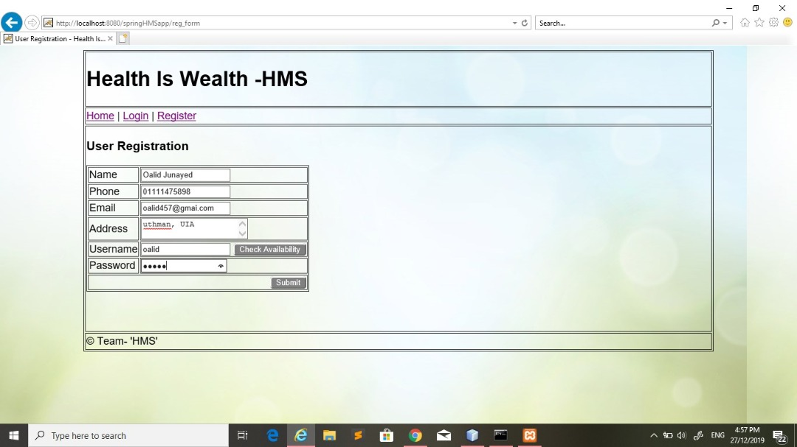

Image: 1

ii) Login

Users who have used the application before can directly login to the system.

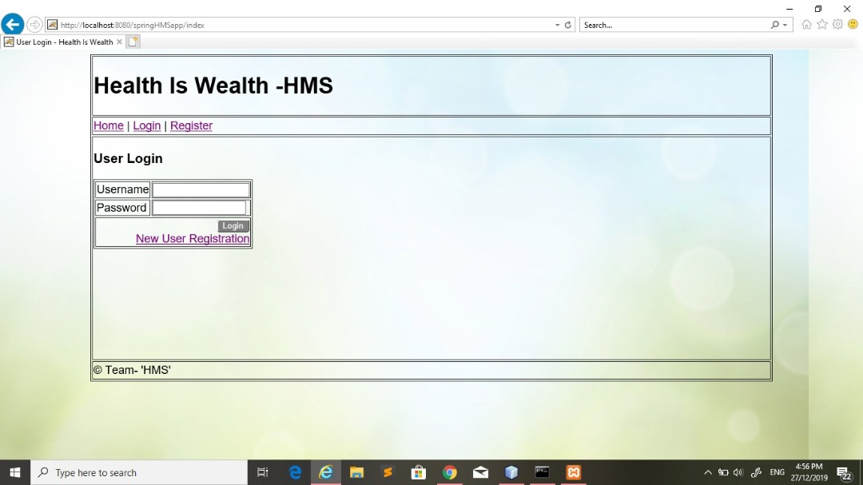

Image: 2

iii) BMI Weight check functionality

This feature is the main feature of the application where users can enter their height and weight to calculate their BMI. Once calculated, the system will show whether the user is normal, underweight or overweight.

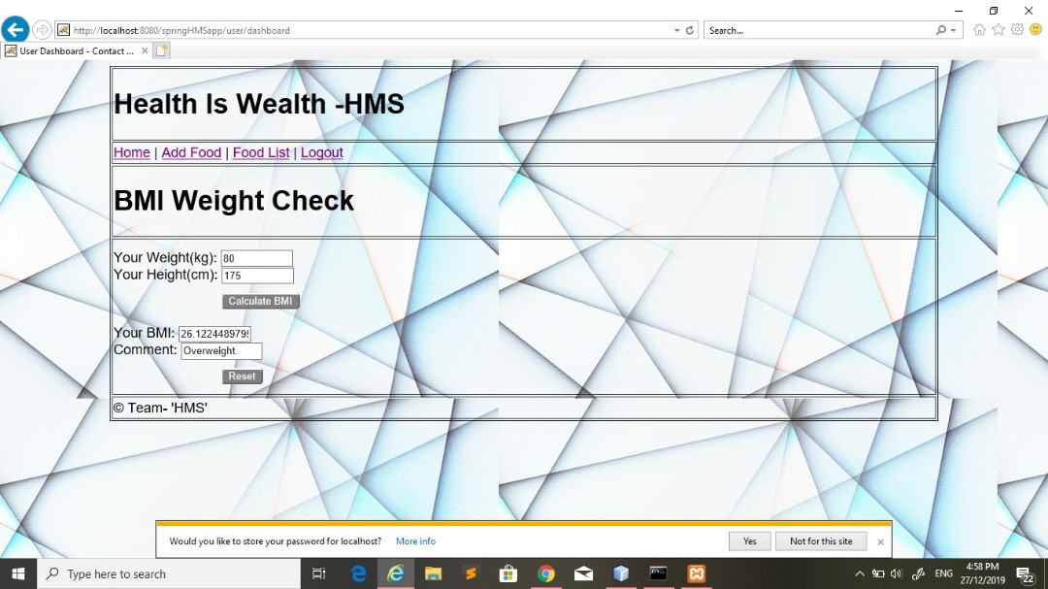

Image: 3

iv) Add food details

In this feature, users can make notes of what they are eating daily so as to track what they are eating.

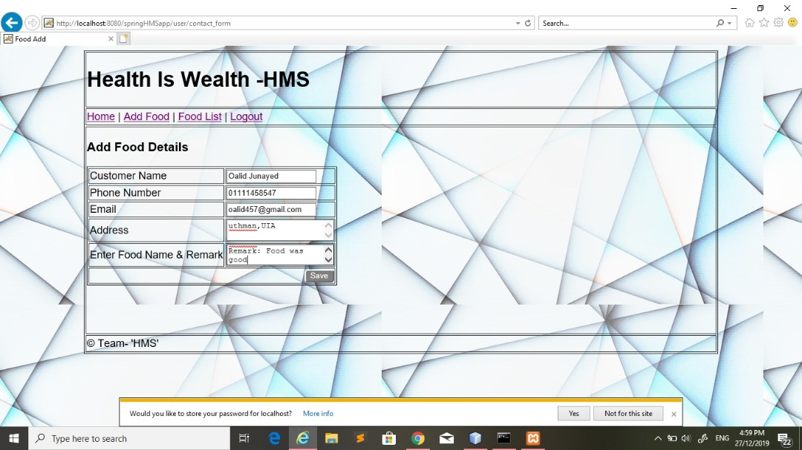

Image: 4

v) Food list

This is a list of food that users have been consuming.



Image: 5

**1.4 VIEWS**

The view is every page we see on a website just like home page, registration page and contact page. A website might have had a lot of functionality on one page. It will not be an efficient method to create page for each function. Therefore, a fixed template is used for one specific page and that page shows different functionalities of a website. In 1.3 above, the “User Registration” and “User Login” page was demonstrated and described. Here the different views of the “User Registration” and “User Login” is shown in the image 6 and 7 for the “Login Page” and “Registration Page” respectively. After the user successfully registers, the user is asked to login again to access the features. In image 7, there is a comment to the user that the username is registered and the user should choose another username.

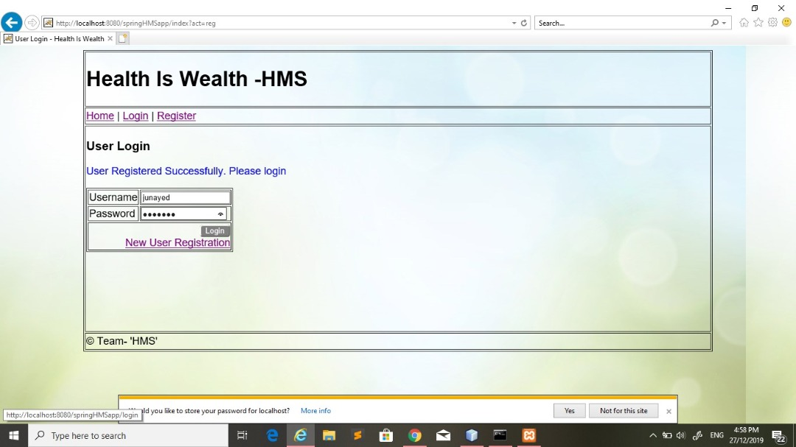

Image: 6

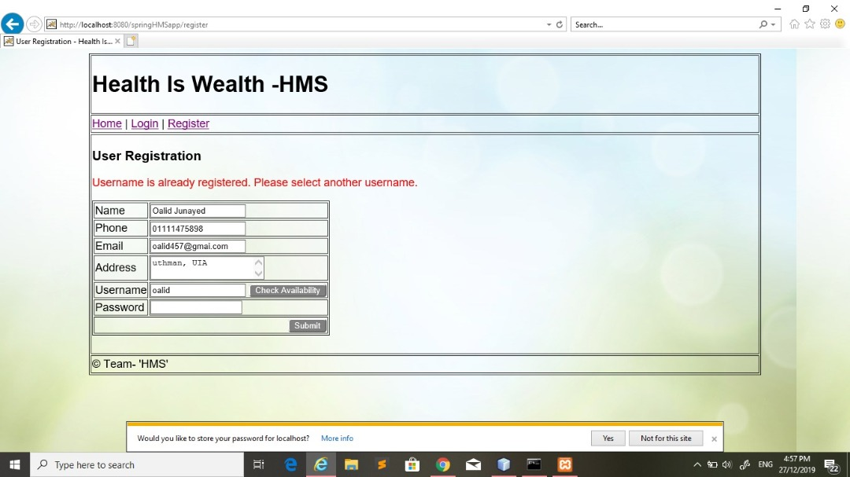

Image: 7

.

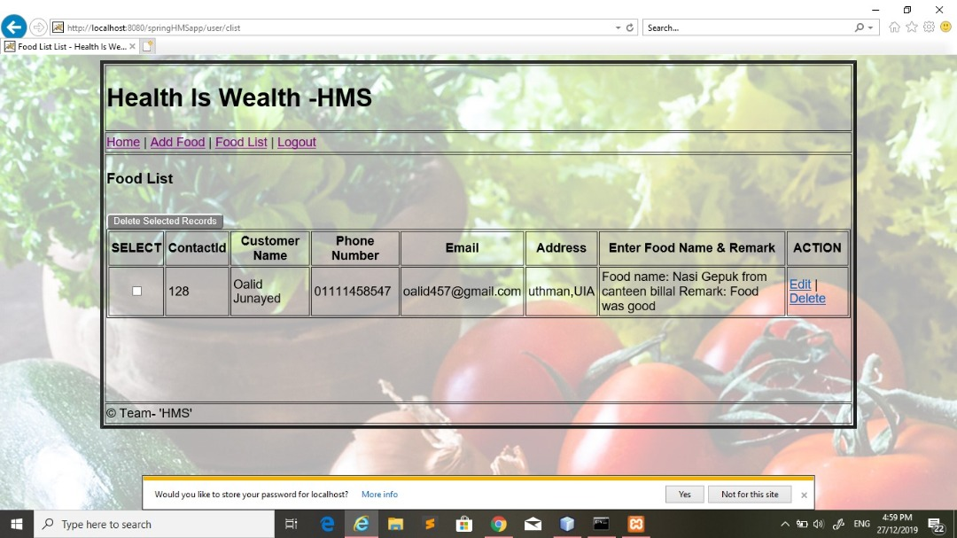

Image: 8

Image 9 and 10 respectively show the database where the data are stored.

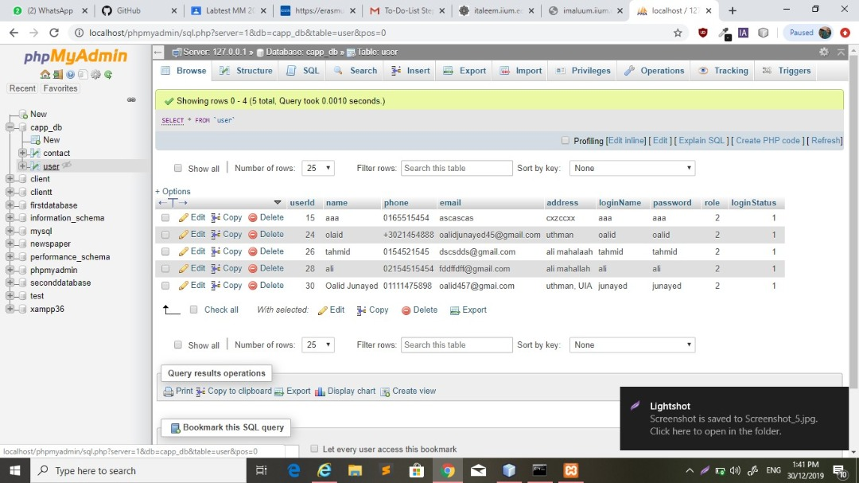

Image: 9

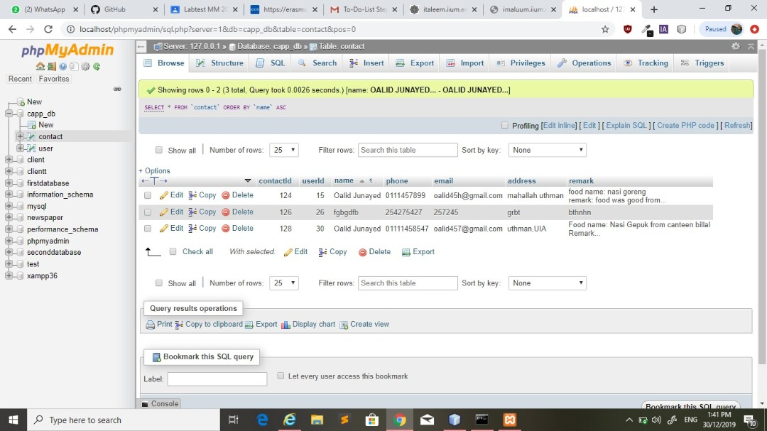

Image: 10

**1.5 SEQUENCE DIAGRAM**

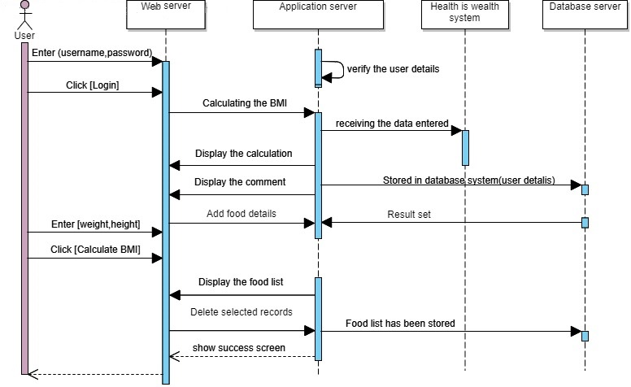

**1.6 USE CASE DIAGRAM**

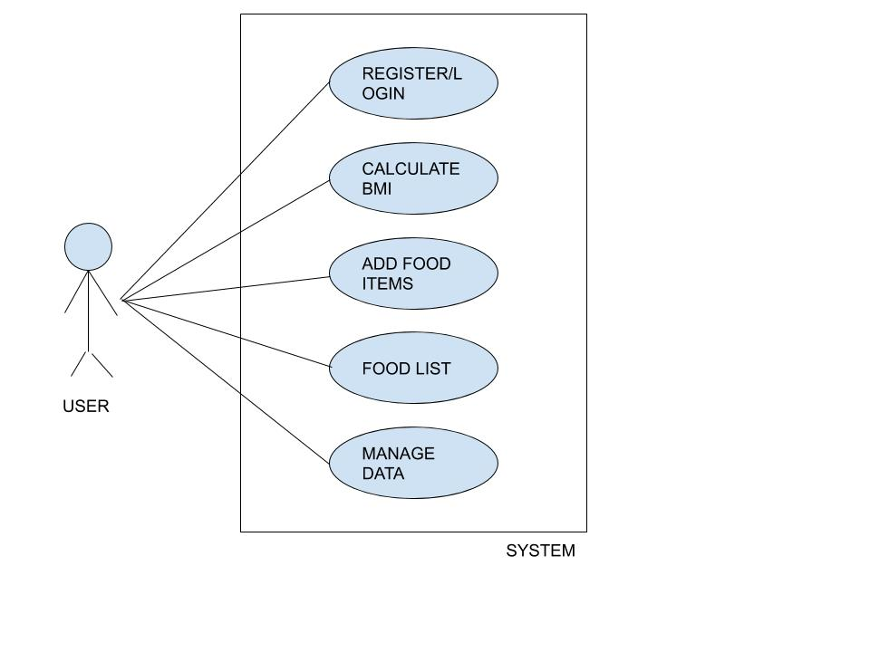

**1.7 REFERENCES**

A. Yunus, F. Fong, Jay. (2019). Many young Malaysians not healthy because of their lifestyle. Retrieved from <https://www.nst.com.my/news/nation/2017/11/303943/many-young-malaysians-not-healthy-because-their-lifestyle>

# Java program to calculate Body Mass Index (BMI)

<https://www.tutorialspoint.com/java-program-to-calculate-body-mass-index-bmi>

Body Mass Index (BMI) is a measure of health based on height and weight. It can be calculated by taking your weight in kilograms and dividing it by the square of your height in meters. (2017)

<https://codereview.stackexchange.com/questions/158197/bmi-calculator-in-java>

<https://github.com/>

<https://stackoverflow.com/>

<https://spring.io/>

<https://www.geeksforgeeks.org/>